**Using Task Scheduler with PowerShell Scripts**

**Step 1:** Open Control Panel => Administrative Tools => Select Task Scheduler

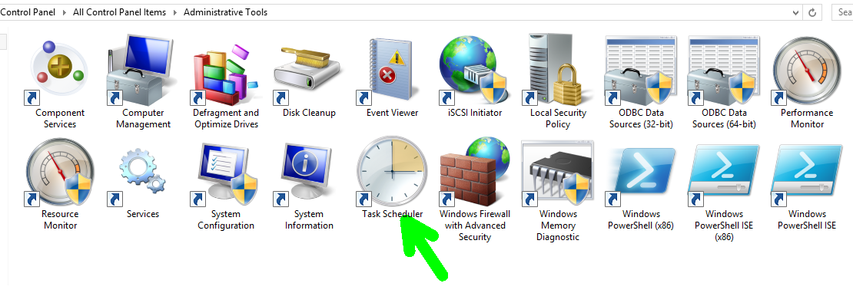

**Step 2:** That will open up an interface of Task Scheduler

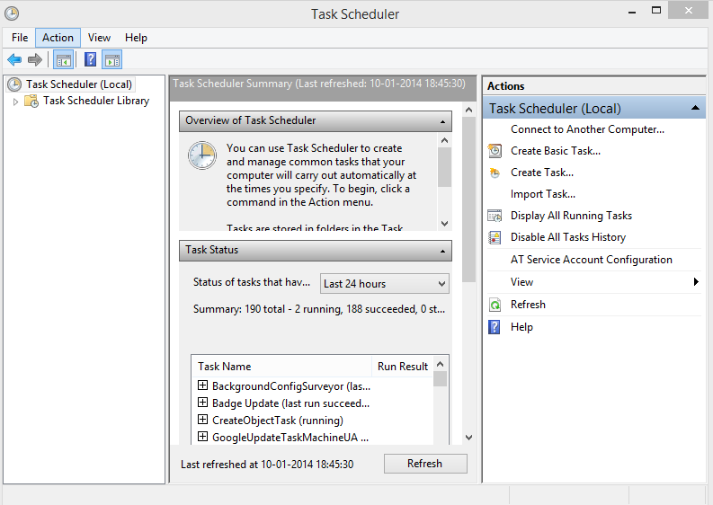

Step 3: Click Create Task On The Top Right Corner of Interface.

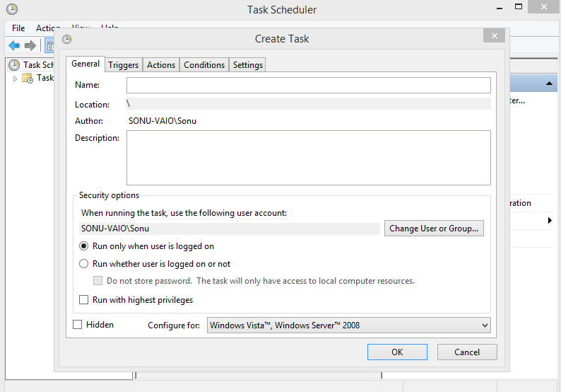

Step 4: General Information i.e. your script name, description and autherization.

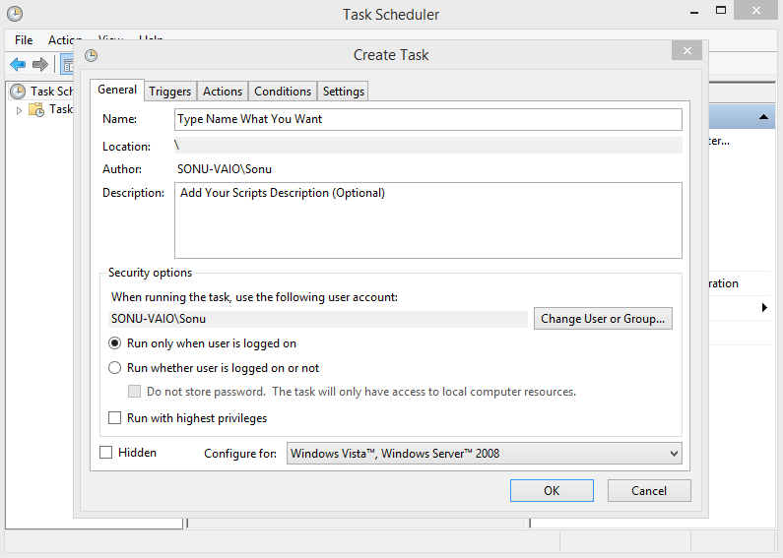

Step 5 : Add / Edit Trigger Event i.e. When should task scheduler should run your script or program.

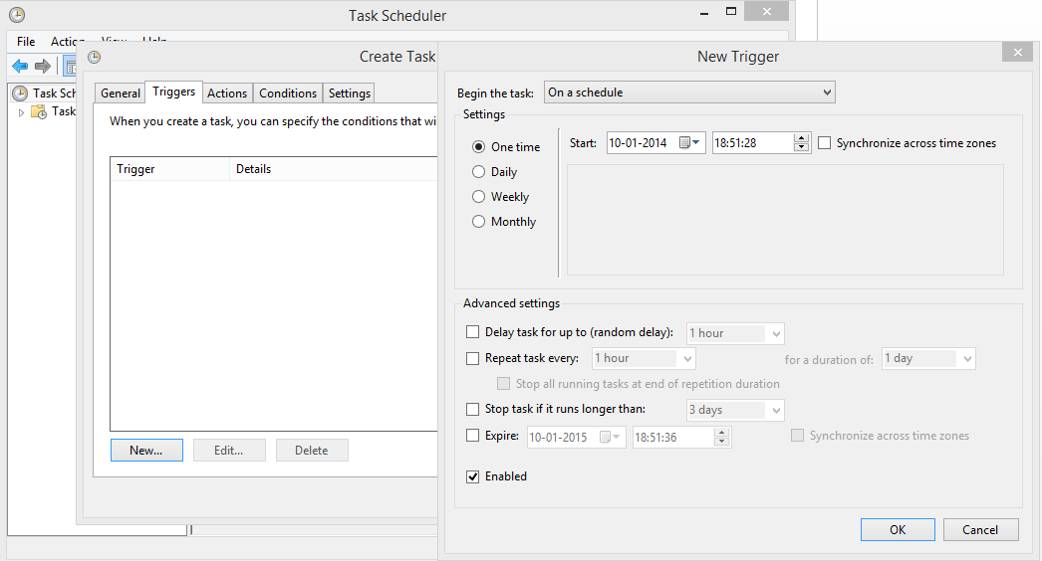

Step 6: Actions Tab Represents Which Program to run and with what arguments.

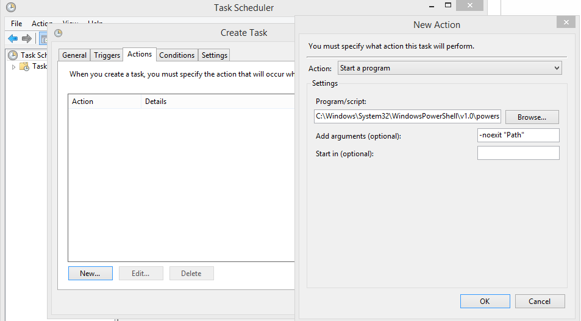

Step 7: Condition Tabs Will Ask you about what should action do when some environments change.

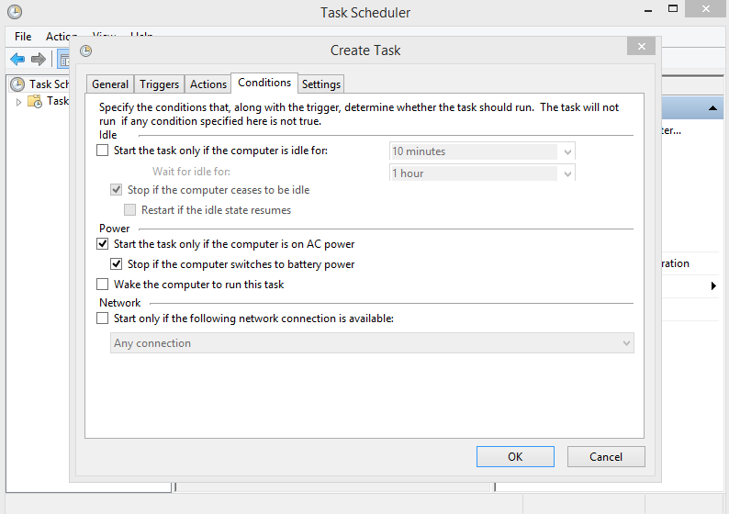

Step 8: Setting Tab to Specify Different Task Related Option.

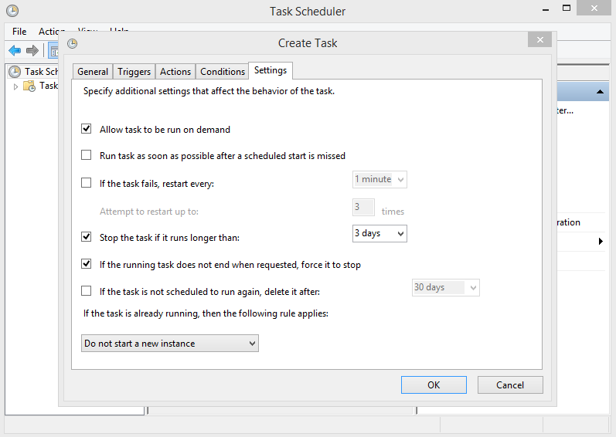

Step 9: Your Task Would be added and would be in ready state and will trigger when the specified interval or time matches.

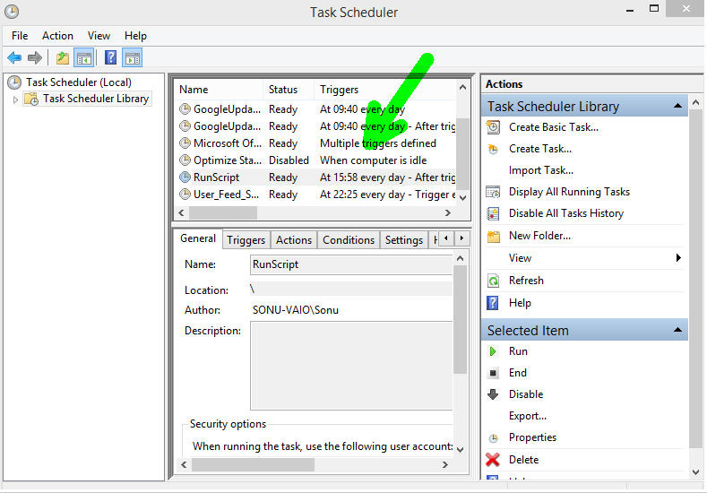

Step 10: Your can run your task independently from the plane in the Right Plane More Tasks.

